Scan Converting a Ellipse:

The ellipse is also a symmetric figure like a circle but is four-way symmetry rather than eight-way.

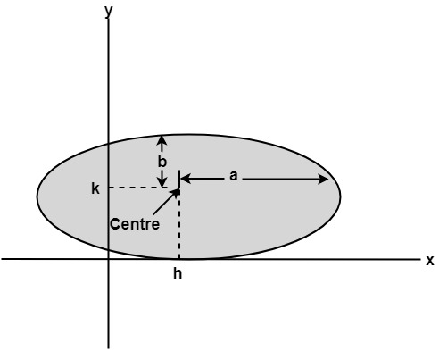

Program to Implement Ellipse Drawing Algorithm:

1. #include<stdio.h>
2. #include<conio.h>
3. #include<graphics.h>
4. #include<math.h>
5. **void** disp();
6. **float** x,y;
7. intxc,yc;
8. **void** main()
9. {
10. intgd=DETECT,gm,a,b;
11. **float** p1,p2;
12. clrscr();
13. initgraph(&gd,&gm,"c:\\turboc3\\bgi");
14. printf("*** Ellipse Generating Algorithm ***\n");
15. printf("Enter the value of Xc\t");
16. scanf("%d",&xc);
17. printf("Enter the value of yc\t");
18. scanf("%d",&yc);
19. printf("Enter X axis length\t");
20. scanf("%d",&a);
21. printf("Enter Y axis length\t");
22. scanf("%d",&b);
23. x=0;y=b;
24. disp();
25. p1=(b*b)-(a*a*b)+(a*a)/4;
26. **while**((2.0*b*b*x)<=(2.0*a*a*y))
27. {
28. x++;
29. **if**(p1<=0)
30. p1=p1+(2.0*b*b*x)+(b*b);
31. **else**
32. {
33. y--;
34. p1=p1+(2.0*b*b*x)+(b*b)-(2.0*a*a*y);
35. }
36. disp();
37. x=-x;
38. disp();
39. x=-x;
40. delay(50);
41. }
42. x=a;
43. y=0;
44. disp();
45. p2=(a*a)+2.0*(b*b*a)+(b*b)/4;
46. **while**((2.0*b*b*x)>(2.0*a*a*y))
47. {
48. y++;
49. **if**(p2>0)
50. p2=p2+(a*a)-(2.0*a*a*y);
51. **else**
52. {
53. x--;
54. p2=p2+(2.0*b*b*x)-(2.0*a*a*y)+(a*a);
55. }
56. disp();
57. y=-y;
58. disp();
59. y=-y;
60. delay(50);
61. }
62. getch();
63. closegraph();
64. }
65. **void** disp()
66. {
67. putpixel(xc+x,yc+y,7);
68. putpixel(xc-x,yc+y,7);
69. putpixel(xc+x,yc-y,7);
70. putpixel(xc+x,yc-y,7);
71. }

**Output:**

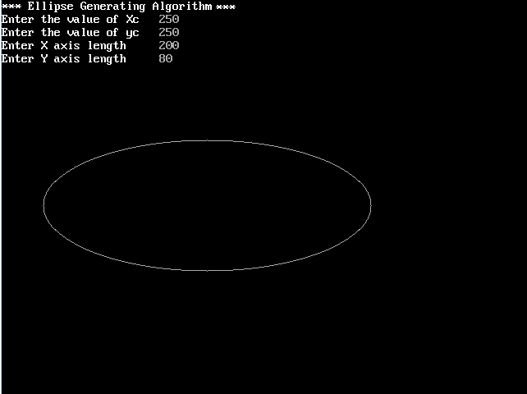

There two methods of defining an Ellipse:

1. Polynomial Method of defining an Ellipse
2. Trigonometric method of defining an Ellipse